**PIZZA SALES QUERIES**

* **KPI’S**

1. **TOTAL REVENUE**

SELECT SUM(total_price) AS TOTAL_REVENUE FROM pizza_sales

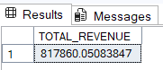

1. **AVERAGE ORDER VALUE**

SELECT (SUM(total_price)/ COUNT(DISTINCT(order_id))) AS AVG_ORDER_VALUE FROM pizza_sales

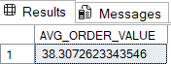

1. **TOTAL PIZZAS SOLD**

* SELECT SUM(quantity) AS TOTAL_PIZZAS_SOLD FROM pizza_sales



1. **TOTAL ORDERS**

* SELECT COUNT(DISTINCT(order_id)) AS TOTAL_ORDER FROM pizza_sales



1. **AVERAGE PIZZAS PER ORDER**

* SELECT CAST(CAST(SUM(quantity) AS DECIMAL(10,2))/CAST(COUNT(DISTINCT(order_id)) AS DECIMAL(10,2)) AS DECIMAL(10,2)) FROM pizza_sales



* **DAILY TREND FOR TOTAL ORDER**

SELECT DATENAME(DW,order_date) AS order_day,COUNT(DISTINCT order_id) AS total_orders

FROM pizza_sales

GROUP BY DATENAME(DW , order_date)

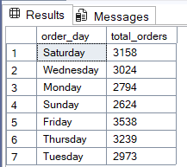

* **MONTHLY TRENDS FOR ORDERS**

SELECT DATENAME(MONTH,order_date) AS Month,COUNT(DISTINCT order_id) AS total_orders

FROM pizza_sales

GROUP BY DATENAME(MONTH,order_date)

ORDER BY total_orders DESC

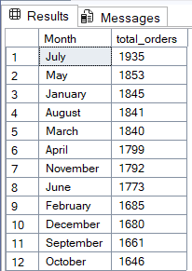

* **% of Sales by Pizza Category**

SELECT pizza_category,

CAST(SUM(total_price) AS DECIMAL(10,2)) AS total_revenue ,

CONCAT(CAST(SUM(total_price)*100/(SELECT SUM(total_price) FROM pizza_sales ) AS DECIMAL(10,2)),'%') AS PCT

FROM pizza_sales

GROUP BY pizza_category

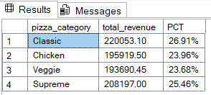

* **% of Sales by Pizza Size**

SELECT pizza_size,

CAST(SUM(total_price) AS DECIMAL(10,2)) AS total_revenue ,

CONCAT(CAST(SUM(total_price)*100/(SELECT SUM(total_price) FROM pizza_sales ) AS DECIMAL(10,2)),'%') AS PCT

FROM pizza_sales

GROUP BY pizza_size

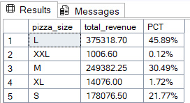

* **Total Pizzas Sold by Pizza Category**

SELECT pizza_category,

SUM(quantity) AS Total_Quantity_Sold

FROM pizza_sales

GROUP BY pizza_category

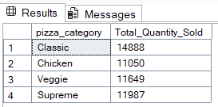

* **Top 5 Pizzas by Revenue**

SELECT TOP 5 pizza_name,

SUM(total_price) AS Total_Revenue

FROM pizza_sales

GROUP BY pizza_name

ORDER BY Total_Revenue DESC

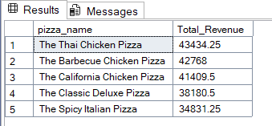

* **Bottom 5 Pizzas by Revenue**

SELECT TOP 5 pizza_name,

SUM(total_price) AS Total_Revenue

FROM pizza_sales

GROUP BY pizza_name

ORDER BY Total_Revenue ASC

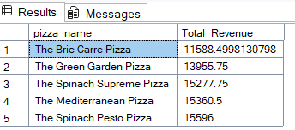

* **Top 5 Pizzas by Quantity**

SELECT TOP 5 pizza_name,

SUM(quantity) AS Total_qauntity_sold

FROM pizza_sales

GROUP BY pizza_name

ORDER BY Total_qauntity_sold DESC

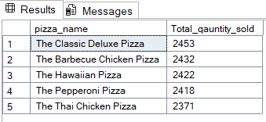

* **Bottom 5 Pizzas by Quantity**

SELECT TOP 5 pizza_name,

SUM(quantity) AS Total_qauntity_sold

FROM pizza_sales

GROUP BY pizza_name

ORDER BY Total_qauntity_sold ASC

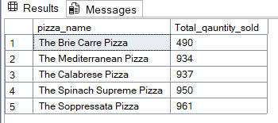

* **Top 5 Pizzas by Total Orders**

SELECT TOP 5 pizza_name,

COUNT(DISTINCT order_id) AS Total_Order

FROM pizza_sales

GROUP BY pizza_name

ORDER BY Total_Order DESC

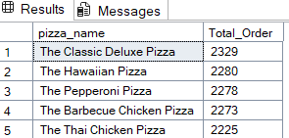

* **Bottom 5 Pizzas by Total Orders**

SELECT TOP 5 pizza_name,

COUNT(DISTINCT order_id) AS Total_Order

FROM pizza_sales

GROUP BY pizza_name

ORDER BY Total_Order ASC

